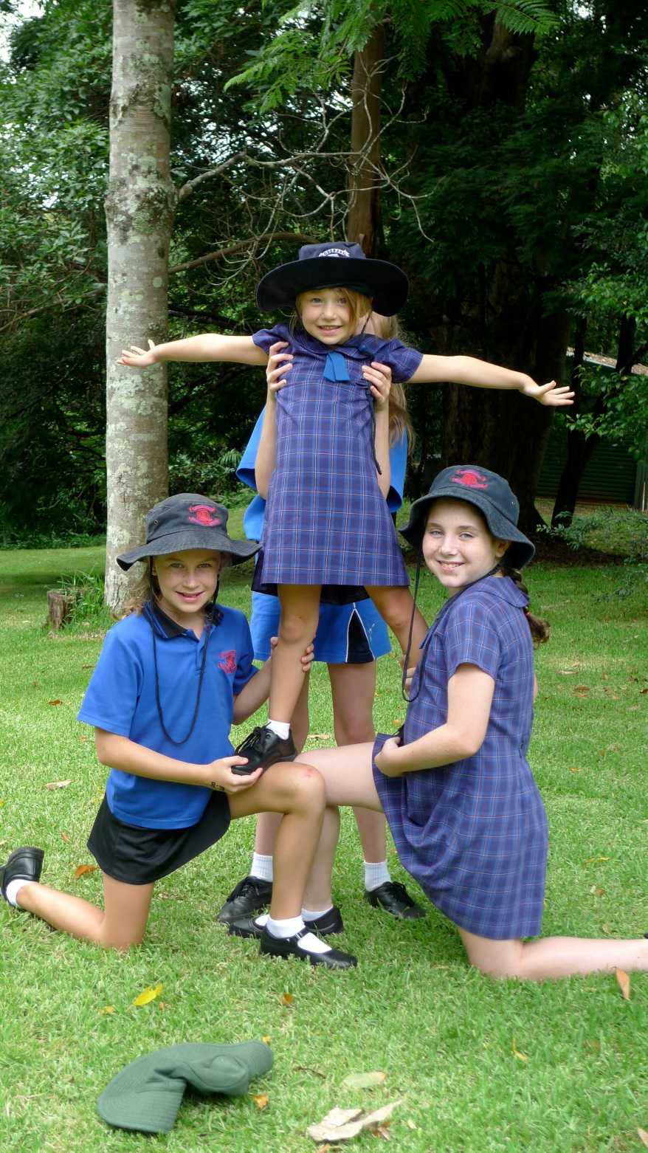
Rosebank Public School

Anti-Bullying Plan

2012
Ratified by the P&C Committee 30.7.12
At Rosebank Public School, we believe that all children should look forward to coming to school, where they will learn and play together in an environment that is safe, supportive, harmonious and fun.
We actively encourage and enable all students to daily enact our shared values of Respect, Integrity, Safety and Excellence. In line with these values, and consistent with NSW Department of Education policy, Rosebank Public School explicitly rejects all forms of bullying.
Bullying of any kind is unacceptable at Rosebank Public School
No one has the right to bully another person
No one has to tolerate bullying
Anyone who experiences or witnesses bullying has a responsibility to immediately report the bullying
What is bullying?

Bullying is repeated verbal, physical, social or psychological behaviour that is harmful and involves the misuse of power by an individual or group towards one or more persons. Cyberbullying refers to bullying through information and communication technologies.
Bullying can involve humiliation, domination, intimidation, victimisation and all forms of harassment including that based on sex, race, disability, homosexuality or transgender. Bullying of any form or for any reason can have long-term effects on those involved including bystanders.

Bullying behaviour can be:
Physical | Examples include punching, hitting, pushing, kicking, tripping, poking, shoving, spitting, obscene gestures, taking, hiding or damaging people’s belongings
Verbal | Examples include name-calling, teasing, belittling others’ abilities or achievements, swearing, put-downs, making degrading comments about another person’s culture, religious or social background, ridiculing another’s appearance, using threatening words
Social | Examples include shutting people out of groups, ignoring, group secrets, cyber bullying, note-passing, mimicking, making rude gestures
Psychological | Examples include rumours, dirty looks, hiding or damaging possessions, writing offensive notes or graffiti, threatening, pulling faces, passing notes, stares and whispers.
Cyberbullying | Examples include sending malicious or unwanted SMS messages or emails, posting negative comments on Facebook

Conflict or fights between equals or single incidents are not defined as bullying.

Our Plan
Our plan has been developed in line with the following five principles:
- Rosebank PS will not tolerate bullying of any kind
- Students who bully others can and must change their behaviour
- Harm caused must be acknowledged
- Reparation (making amends) is essential
- Children who have been bullied and those who have engaged in bullying both need support; however the rights of the person bullied must be privileged
- Anyone who experiences or witnesses bullying of any kind must report it.
Why do we need a plan?
Children who are bullied are at risk of a range of negative health and achievement outcomes, including an increased risk of anxiety and depression. Young people who bully others are also more likely to experience a range of difficulties in later life.
Children who bully others have often been bullied themselves. It is very important that schools take timely and positive action to support children who have been bullied and those who have bullied others in order to prevent negative outcomes for all children involved and also to interrupt cycles where bullied children later bully others.
Time and space to learn and grow
Being part of a school learning community involves learning to get along with other children. Just as in a family, this isn’t always a smooth ride. Most children experience occasional conflict with other children while at school. This isn’t bullying, but part of the journey.
Occasional interpersonal conflict presents opportunities for mutual learning. Children who have been hurt by someone else’s words or actions can learn strategies for voicing their feelings and responding assertively. Children who have hurt others’ feelings can learn to understand how their behaviour affects others.
In these instances, teachers work with all students involved to help them understand how their behaviours affect others, how their behaviours are viewed by the school community and possible consequences for behaving in that way.
Our goal is to help all children understand how to manage occasional conflict but also to prevent occasional conflict becoming an established and damaging pattern and developing into a bullying relationship. Further, we aim to respond quickly and decisively should bullying occur, so that all children involved are protected, learn from the experience, and go on to enjoy a more happy and harmonious relationship.
Our plan to prevent and respond to student bullying forms part of a comprehensive framework of connected policies, programs, plans and strategies. Together, these comprise Rosebank Public Schools Wellbeing Framework. Our Wellbeing Framework can be viewed on our school website.

Preventing bullying at Rosebank
Bullying can have serious consequences for everyone: Children who experience bullying behaviour, those who engage in it and bystanders as well.
To prevent student bullying, teachers model, describe and explicitly teach positive behaviours, give students opportunities to rehearse those behaviours and acknowledge them when they interact supportively. That is, teachers help students form respectful relationships with one another.
The active teaching of valued (positive) behaviours occurs during PBL and You Can Do It! lessons where children learn what valued behaviours look like, sound like and feel like. Students also have opportunities to rehearse positive behaviours during role play and other activities.
Children who display valued behaviours are acknowledged through Rosebank Public School’s system of class awards including Student of the Week awards and Community Spirit Awards (Busy Bees).
In addition to the explicit teaching of positive behaviour, children at Rosebank learn what bullying is, what is looks like, sounds like and feels like and what they should do about it. They also learn about their important role should they be a bystander when bullying occurs, how they should intervene and support any person being bullied and report all bullying to a teacher.

Responding to bullying at Rosebank
Where students have been observed engaging in, or found to have engaged in, bullying, our response will be clear, strong and carefully considered.
Teachers responding to reports of bullying act with the intention of supporting the child who has been bullied, the child who has engaged in bullying, and affected bystanders. First, the bullying must stop. Then, we seek to help all parties learn from the experience and avoid future negative consequences.
Responsibilities: Bullying
Our principal has a responsibility to:
- consult with our community to formulate an Anti-Bullying Plan
- investigate reports of student bullying
- informs parent/s of child who has been bullied of planned actions and outcomes
- lead teachers to identify consistent responses to behaviour then cooperates with teachers to promote consistent teacher responses
- informs parent/s of child who has been bullied of planned actions and outcomes
- applies consequences as outlined in Consistent Responses to Behaviour
- communicates information to the school community about Rosebank Public School’s Anti-bullying Plan
- implement an annual Anti-Bullying Action Week to target teaching about bullying, how to respond and its effects.
Teachers have a responsibility to:
- develop close, warm relationships of trust with students so that they feel comfortable to share their feelings about the behaviour of others
- respond in a timely manner to incidents of bullying in line with the school’s Anti-Bullying Plan and PBL framework
- adopt positive classroom management strategies, including the modelling of positive behaviour
- actively teach valued (positive) behaviours across a range of school settings
- teach children what bullying is and how to respond if bullied
- teach children what it means to “stand up for what is right”, including speaking up or taking action if they see or become aware that someone else is being bullied
- engage in active supervision when on duty during recess and lunch times, as a deterrent to possible incidents of bullying
- recognise and reward children who form respectful relationships with others
- have knowledge of school and departmental policies and procedures in relation to preventing and responding to bullying.
Students have a responsibility to:
- engage in positive behaviour, respecting individual difference and diversity
- behave as responsible digital citizens
- follow the school Anti-Bullying Plan
- behave as responsible bystanders, standing up for what is right and reporting all bullying to a teacher or parents
- participate actively in class learning about valued behaviours
- NEVER bully another child or children.
Parents have a responsibility to:
- Support their children to become responsible citizens and to develop responsible online behaviour
- Be aware of the school Anti-Bullying Plan and assist their children to understand bullying behaviour
- Support their children in developing positive resopnses to incidents of bullying consistent with the school’s Anti-Bullying Plan
- Report incidents of school-related bullying to the school as soon as possible
- Work collaboratively with the school to resolve incidents of bullying when they occur.
Members of the school community (eg: school bus drivers) have a responsibility to:
- model and promote positive relationships that respect and accept individual differences and diversity within the school community
- support the school’s Anti-Bullying Plan through words and actions
- Works collaboratively with the school to resolve incidents of bullying when they occur.

Is my child is being bullied?
Signs that a child is being bullied might include:
Emotional | Personality changes, mood swings, sleep disturbance, insomnia, nightmares, depression, frequent tears, eating disorders – over/under eating
Physical | Signs of torn clothing, unexplained injury, psychosomatic symptoms (headaches, stomach aches, nausea), negative body language, nervous habits
Social | Loss of confidence, withdrawal from friends, increased sibling rivalry
Behavioural | Outbursts of temper, mood swings, problematic behaviour
School | Unwillingness to go to school, requesting changes to transport, decline in work standards
Home | Unwillingness to leave the house, withdrawal from family members, angry behaviour towards parents and/or siblings, demand for extra money for school
Community | Unwillingness to be out in community or to participate in social events.
I have been bullied before, so I know how it feels. It feels like you’re younger and less capable. It hurts, but Ms Sawyer taught us to stay strong and ignore bullies and they will stop. I did. I fought back and didn’t let them get to me. Now I am bully-free but if another bully tries to get to me, I will not hesitate to stop it.
Lucy, 11 years
Ask your child’s teacher. Share your concerns. Te`achers observe your child and how they interact with others 5 days/week for 40 weeks of the year. They know them well, but are eager to learn from you, your child’s first teacher. When teachers and parents work together, it is easier to form a balanced view.
What should I do if I think my child is being bullied?
It is vital that you or your child tell a teacher if they/you feel that they have been humiliated, intimidated, dominated, victimised, harassed or excluded at school.
Your child’s teacher will listen to concerns raised and take action. They will also inform the school principal.
Bullies gain power when those they have bullied remain silent. This makes our school less safe and happy for all students.We teach our students that seeking help is not “dobbing”, but standing up for what is right.
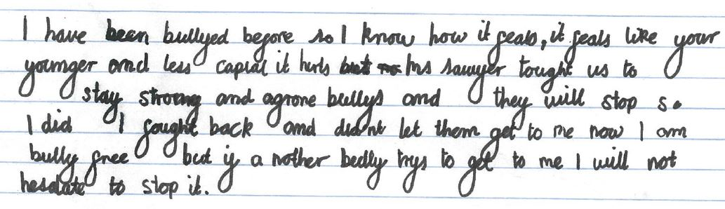
Shining a light on the behaviour of students who are not treating others with kindness helps make sure that all students’ experience of school life at Rosebank is consistent with our shared values: Respect, Integrity, Safety and Excellence.
Investigating reports of bullying
When the principal receives a report of bullying, she/he will:
- Speak with students involved (including bystanders) and ask for a personal account. Sometimes, this account is drawn or given in writing, depending on the age of the student
- Consider all accounts and that of the supervising teacher
- Form a view of what has happened and communicate that view to students involved and consequences as applicable. This is likely to involve a meeting of all students involved, where expectations in relation to positive behaviour will be re-stated and consequences explained
- Where a student has been subject to bullying behaviour, the teacher or principal will advise the parent/s of that student. Plans will be made to support the student, including ways that the student who engaged in bullying can make amends.
- Where a student is believed to have bullied another student, the parent/s of the student who engaged in bullying will be advised. Plans will be made to help that student take responsibility for his/her actions, make amends, and learn more positive behaviour.
Whenever a child tells a teacher or the principal that they have been bullied or have witnessed behaviour that might constitute bullying, they are told that they have done the right thing in coming forward. Children who have been bullied or who have reported bullying will receive support as needed, including support from our School Counsellor if necessary.
It is vital that children who report the inappropriate behaviour of others are not further harassed for doing so. At Rosebank, we teach children that this is not “dobbing” but “standing up for what is right”. Bullies thrive when other children stay silent.

Consequences
A child who has bullied another child or children will be counselled as to behaviour expected by our school community. They will be given specific advice as to the ways in which their behaviour is unacceptable. Their parent/s will be notified and asked to work with the school to help a student who has bullied another child to modify their behaviour.
In line with our Consistent Responses to Behaviour document, possible consequences for repeated bullying – or bullying that involves physical violence – can include a Formal Caution or immediate suspension from school. In the case of physical violence, suspension may occur without any prior caution.
If you’re not part of the solution…
At Rosebank, we teach students that if you are not part of the solution, you are part of the problem. That is, if you do not report bullying AND step in if you see someone being bullied, you make the bully more powerful.
Rosebank children are not to engage in any of the following behaviours:
- ignoring or remaining silent about bullying behaviour,
- providing the student who is bullying with social reinforcement (making them feel cool or special)
- making person who is being bullied feel even worse by staying away from them
- gossiping about things that have happened, which can make a person who engages in bullying behaviour seem important and powerful
- verbally encouraging bullying behaviour
- laughing or smiling at the bullying, or preventing the student who is being bullied from escaping the situation
- shielding the situation from adult view or acting as ‘lookout’,
- acting as a messenger for students who are bullying
- not telling the truth about bullying behaviour that they have seen.
In addition, Rosebank students are expected to stand up for what is right and always report bullying behaviour. As well, they must take action, as follows:
IF YOU SEE SOMEONE ELSE BEING BULLIED
- Tell the bully to stop, firmly and clearly (eg “You are being a bully. Stop it now.”)
- Tell a teacher, every time
- NEVER watch or join in
- NEVER accuse someone who has reported bullying of “dobbing” . People who report bullying are standing up for what is right.
Students who engage in behaviour that supports, enable or ignores bullying will also receive a consequence.
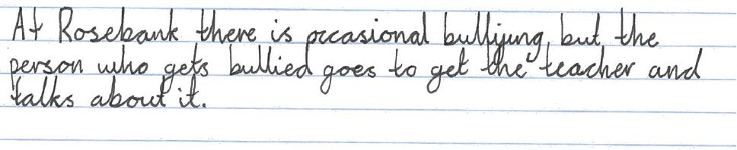Arusha, 11 years

My child is bullying others
Parents can find the news that their child has bullied another child or children difficult to accept. Parents are notified that their child has engaged in bullying when a student or teacher has witnessed and/or reported bullying behaviour, an investigation has concluded that bullying has occurred, and the relevant consequence is to involve the families of students concerned.
Being told that your child has engaged in bullying behaviour can elicit feelings including disbelief, sadness, and/or skepticism. However, a child who engages in bullying needs help. Children who bully others are at risk of a range of negative outcomes if they do not receive appropriate and timely support. The Australian Institute of Family Studies outlines Ten Positive actions for parents whose child is bullying other children, which parents of students who may be involved in bullying might find helpful.
Tips: Handling bullying behaviour
IF YOU ARE BEING BULLIED
- Tell the person to stop “You are being a bully. Stop it now”
- Walk away and tell a teacher
- Tell the Peer Support Leader or another school leader
- Tell the Principal

IF YOU ARE BEING CYBERBULLIED
- Don’t respond to the message or image
- Save the evidence
- Block and delete the sender
- Report the situation to the website or service provider
- Tell trusted people-teachers, parents, adults, friends, police.
Summary of Actions
- Teach all students expected positive behaviours
- Teach all students what bullying is and how to respond
- Require mandatory reporting of all forms of bullying
- Investigate all reports of bullying and apply consequences
- Communicate information to parents about Anti-Bullying Plan
- Implement annual Anti-Bullying Action Week
- Monitor incidents of bullying and report to P&C
Consultation
- Our plan was developed in consultation with students, parents and teachers. Students were asked for their perspectives on bullying at our school and survey data was used to help analyse their responses.
- Parents were provided with a draft plan, and invited to provide feedback. Parent feedback was considered when re-drafting the plan, which was endorsed at a meeting of our P&C on XXXX.
Not happy?
The Department of Education has a procedure for responding to school community and consumer complaints. Should you be dissatisfied with the school’s management of bullying, your first step is usually to discuss your concerns with the Principal so that he/she can attempt to address your concerns at the local level. If the complaint cannot be resolved informally, you may make a written complaint to the Director Public Schools NSW. Information about the department’s complaints handling procedure can be found at the department’s website.
Feedback
If you have feedback on our Anti-Bullying Plan, please contact our School Principal Abigail Sawyer on 6688 2126 or abigail.sawyer4@det.nsw.edu.au
Plan revised:
Endorsed by P&C:
Due for revision:

Lodge, J. (2014). Working with Families whose Child is Bullying: An evidence-based guide for practitioners. Australian Institute of Family Studies CFCA Paper Number 26.

